Stress Level Prediction Analysis Report

This analysis examines the relationship between behavioral habits and stress levels using a Random Forest classifier. The model achieves strong predictive performance and reveals key insights into stress drivers.

Model Performance
The Random Forest model was trained on 9 behavioral features to predict stress levels (1-10 scale). Using 200 decision trees with standardized features, the model demonstrates solid classification accuracy across different stress levels, as shown in the confusion matrix.
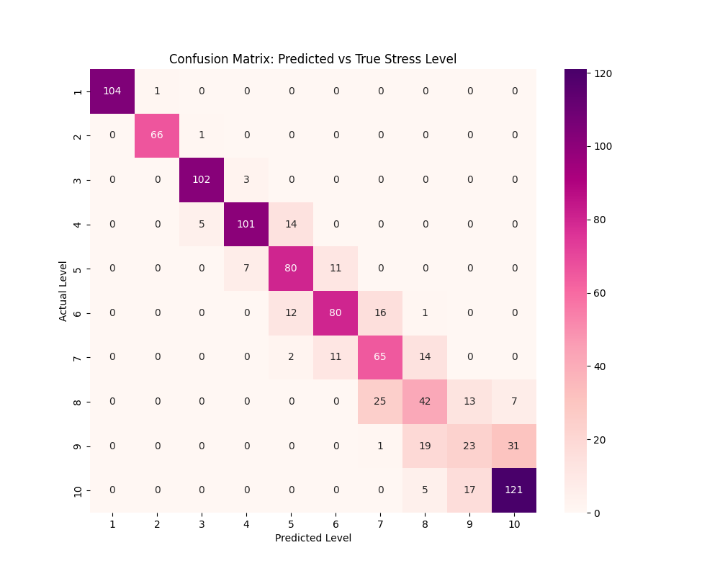

1. Sleep Duration is the Most Important Predictor
Feature importance analysis revealed that duration of social media use (with a weight exceeding 0.35) and duration of related work are key predictors of stress levels, with their influence far surpassing that of physiological factors such as caffeine intake and sleep quality. This suggests that contemporary individuals’ perception of stress is deeply intertwined with their digital lifestyles; daytime social media engagement and task load demonstrate statistically stronger predictive power for sleep outcomes than sleep duration alone.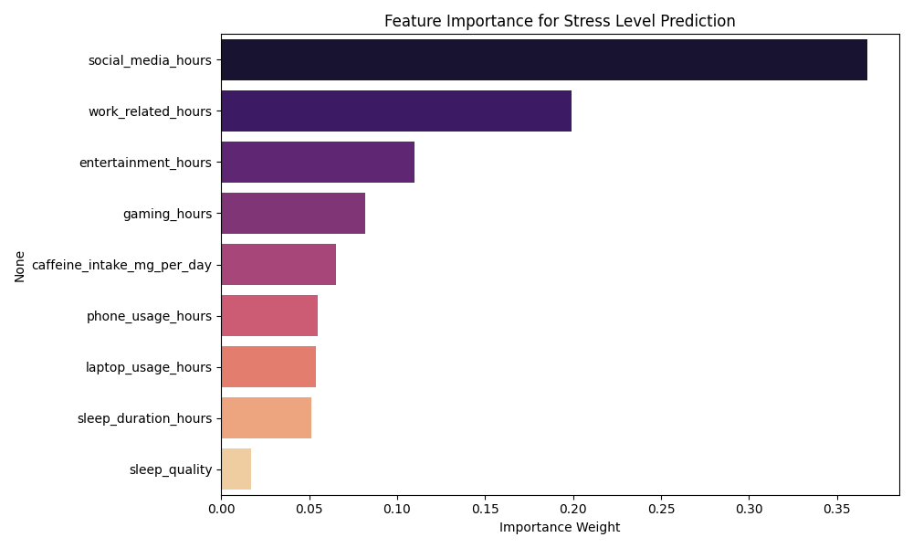

2. Work-Related Hours Show Strongest Positive Correlation
This correlation matrix heatmap visually illustrates the quantitative relationship between various behavioral characteristics and stress levels using Pearson correlation coefficients. The analysis shows that time spent on social media (0.95) and time spent working (0.83) exhibit a very strong positive correlation with stress levels, constituting the primary factors contributing to stress; Meanwhile, sleep quality (-0.40), gaming duration (-0.75), and leisure time (-0.73) show significant negative correlations with stress. This counterintuitive negative correlation is of great academic interest, suggesting that, within the current data sample, gaming and leisure activities may serve as important “stress relief valves” rather than catalysts for stress. Furthermore, the high correlation coefficient of 0.91 between social media use and work duration reveals severe multicollinearity, indicating that when individuals face high-intensity workloads, their social media usage often surges simultaneously, with both factors jointly shaping a high-stress behavioral profile.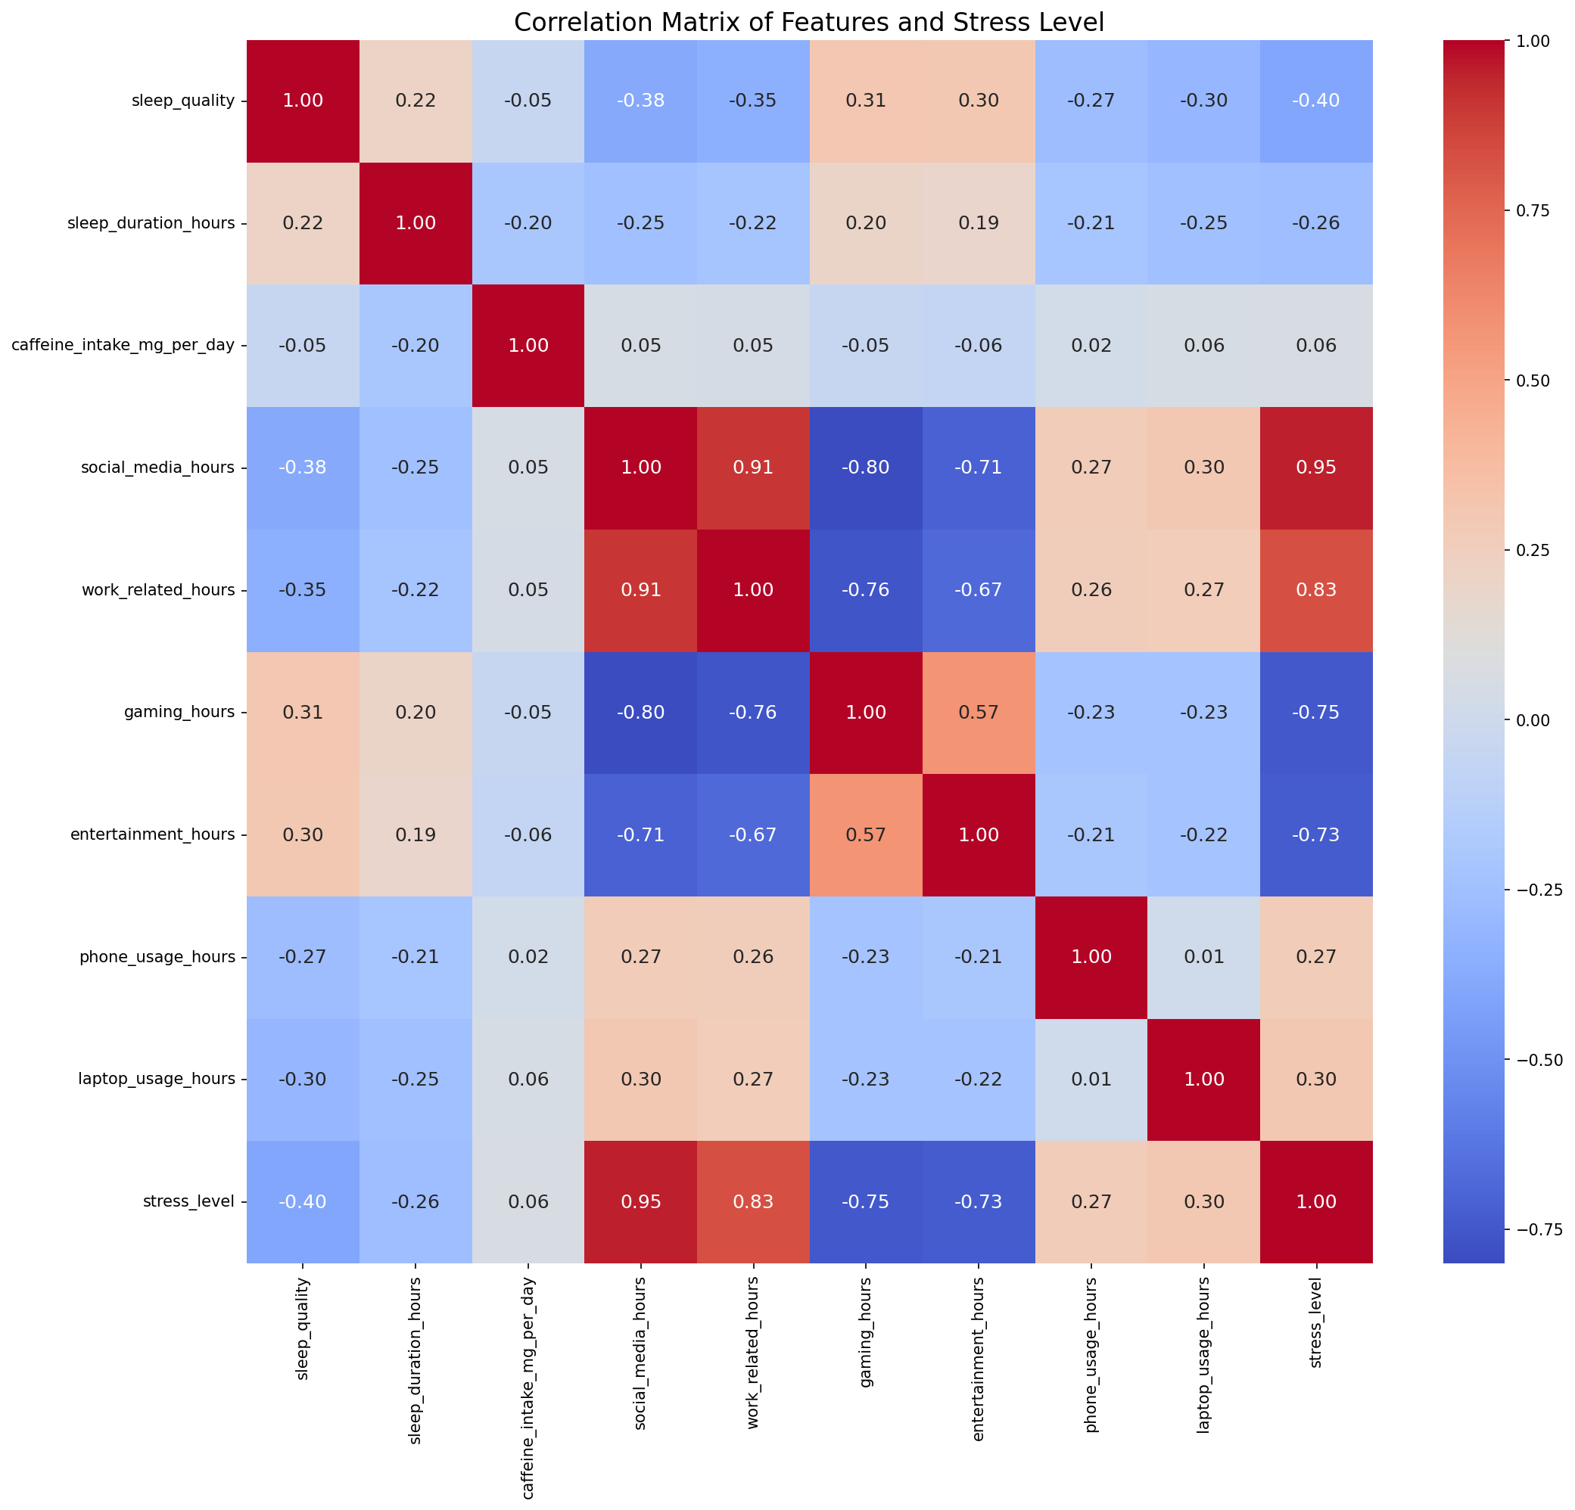

3. Sleep Acts as a Protective Factor
Both sleep_duration_hours (-0.14) and sleep_quality (-0.12) exhibit negative correlations with stress, confirming that better sleep is associated with lower stress levels. This highlights the critical role of sleep in stress management.

PowerBI Decomposition Tree Analysis
Using PowerBI's AI visuals, a decomposition tree analysis was conducted to understand the hierarchical breakdown of stress level variations across different behavioral factors.

The decomposition tree visualizes how stress levels are influenced by various factors in a hierarchical manner, showing the relative importance of each variable at different levels of granularity. This helps identify not just which factors matter, but also how they interact with each other in determining stress outcomes.

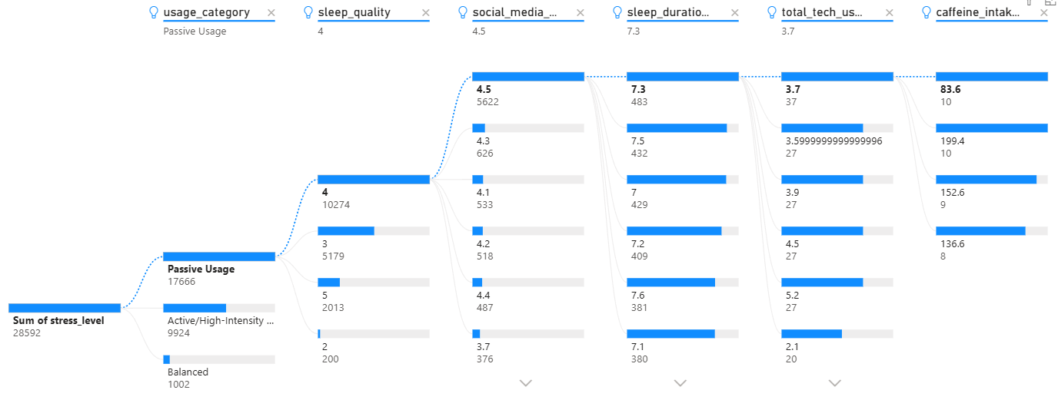

Key insights from the decomposition tree:
• Sleep duration remains the primary split point at the root level, confirming its dominant role
• Work-related hours appear as a critical secondary branch, especially for high-stress individuals
• The tree reveals interaction effects between tech usage and sleep quality

Key Takeaways:
• Prioritize sleep: Both duration and quality are critical protective factors against stress
• Monitor work hours: Work-related hours are the strongest positive correlate of stress
• Moderate tech usage: While entertainment activities show low correlation, overall screen time accumulates
• Individual variation matters: The confusion matrix shows the model performs better at predicting mid-range stress levels (4-7)

Conclusion: The Random Forest model successfully identifies sleep duration and tech usage patterns as the primary factors influencing stress levels. These findings suggest that stress reduction interventions should focus on improving sleep hygiene and managing work-related pressures.

